**MediAid Healthcare Project**

**Phase 4: Process Automation (Admin)**

Process automation in Salesforce ensures that repetitive tasks are minimized, data quality is maintained, and business processes run smoothly with minimal manual effort.

**1. Validation Rules**

* Enforce correct data entry for critical fields.
* Examples:
  + Patient__c: DOB cannot be a future date.

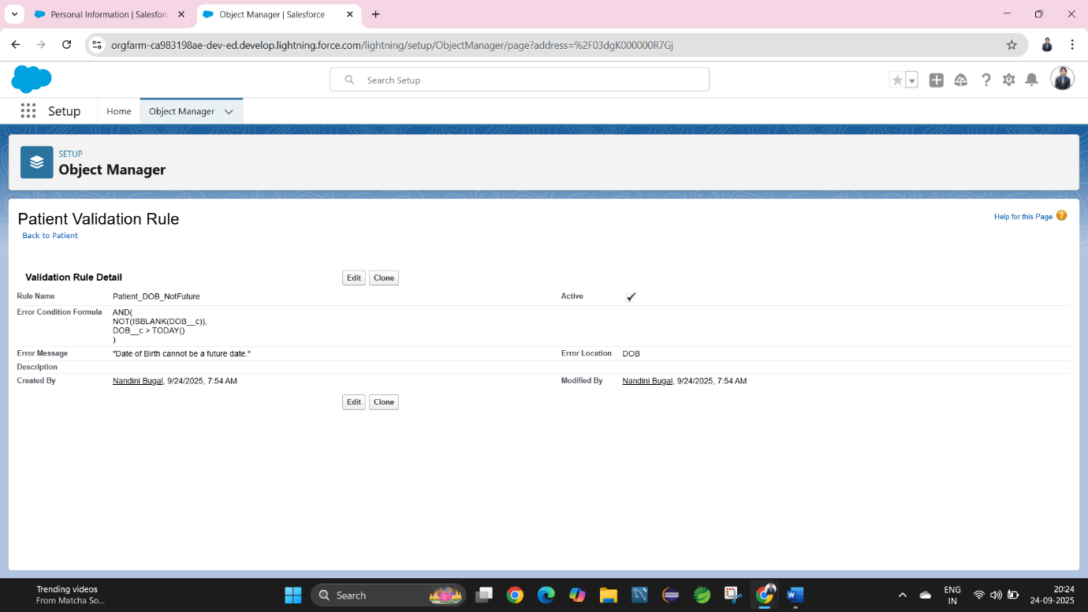

* + Prescription__c: Dosage must be greater than 0.

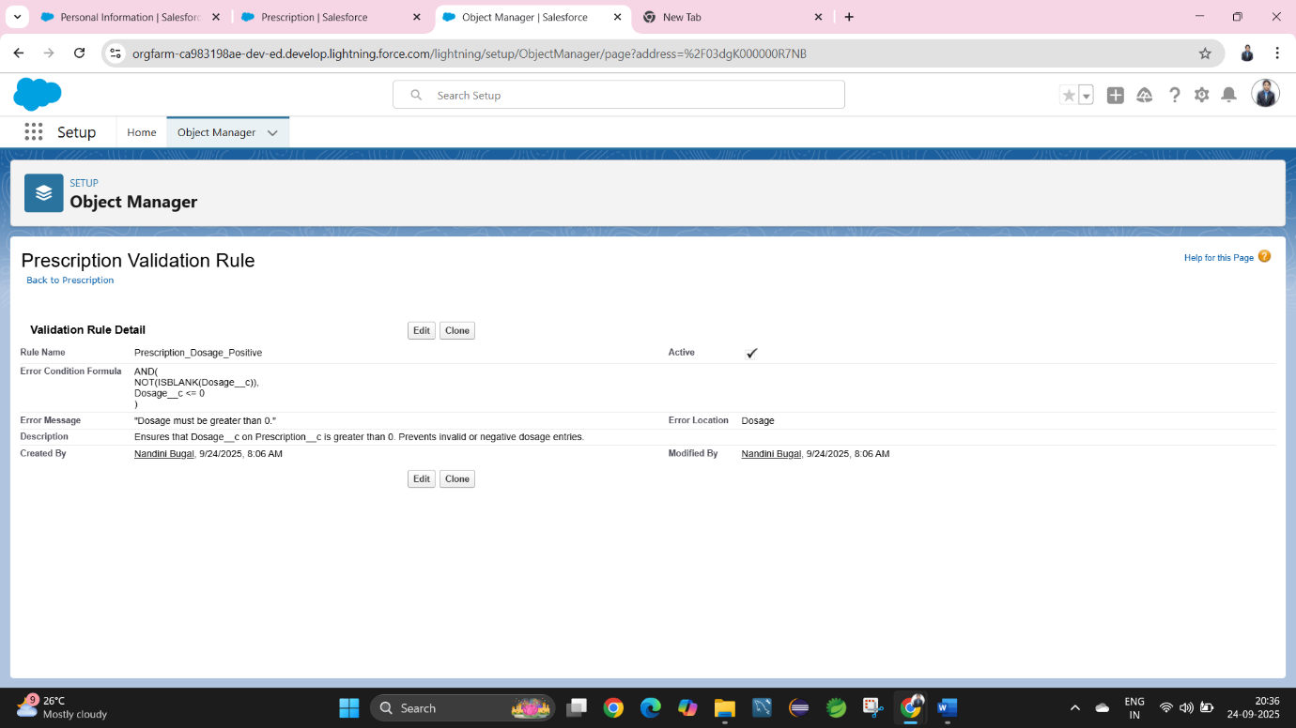

* + Appointment__c: Appointment Date cannot be in the past.

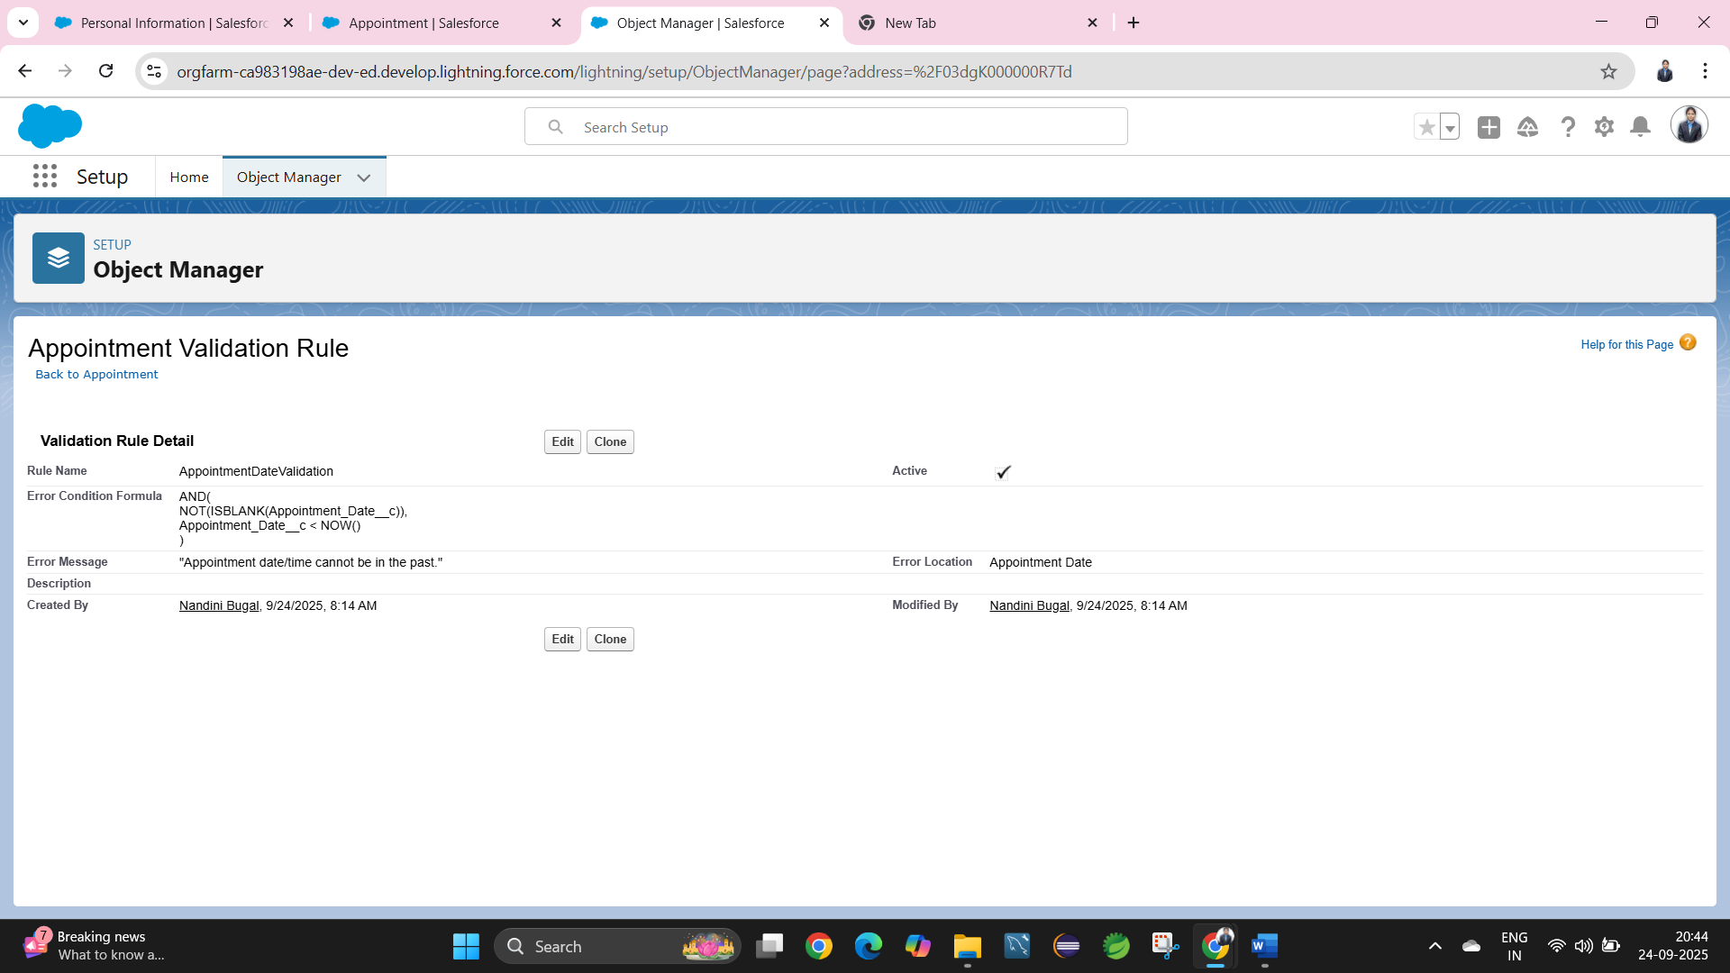

**2. Workflow Rules *(Legacy, but still useful)***

* Automate simple if/then actions.
* Examples:
  + When a **Prescription__c** is created, send an email to the assigned patient.
  + 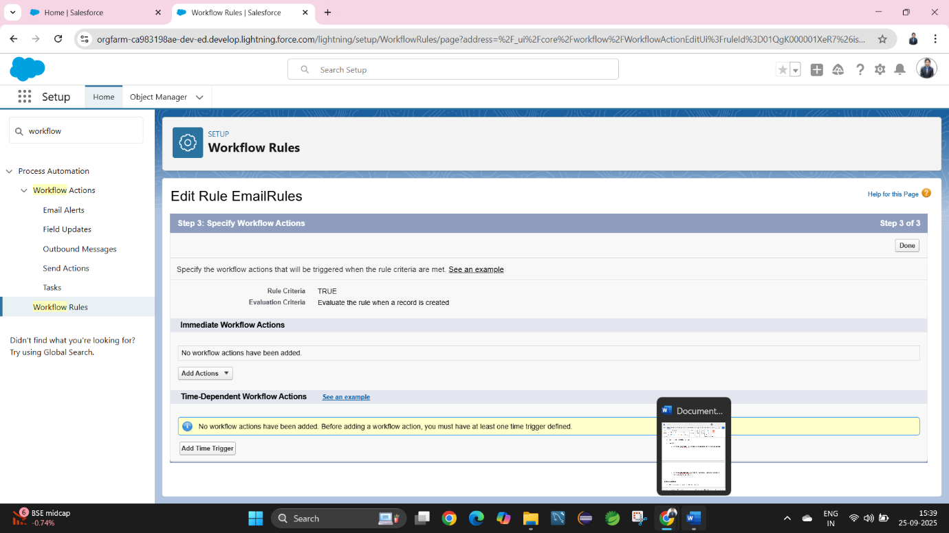

**3. Process Builder**

* Advanced automation with multiple conditions.
* Examples:
  + If a **Patient__c** misses 3 reminders in a row → Update Patient Status = “Non-Adherent” + Notify Caregiver.

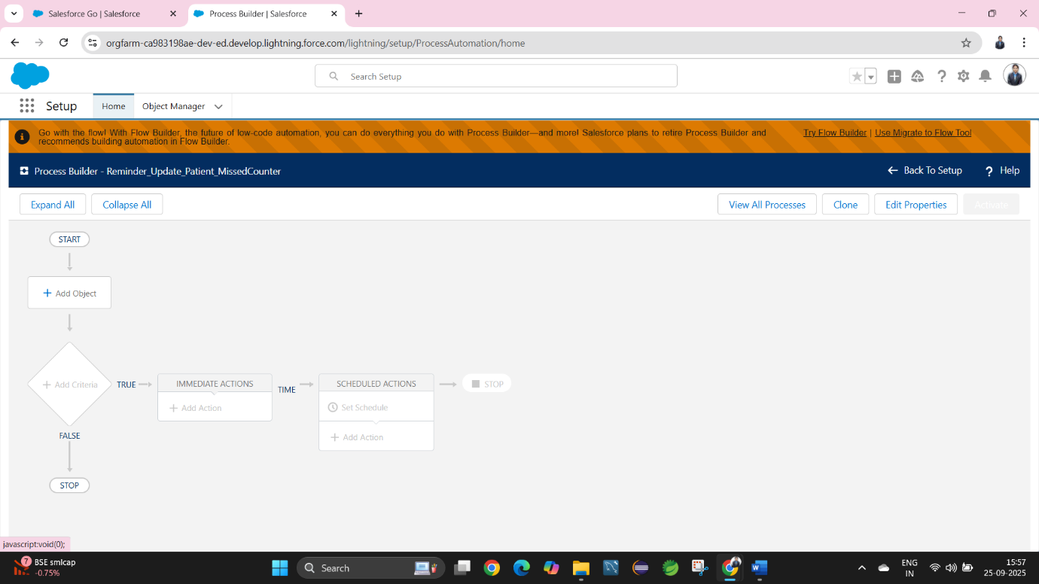

**4. Approval Process**

* Structured approval workflows.
* Examples:
  + Prescription approval by **Senior Doctor** before being sent to Patient.

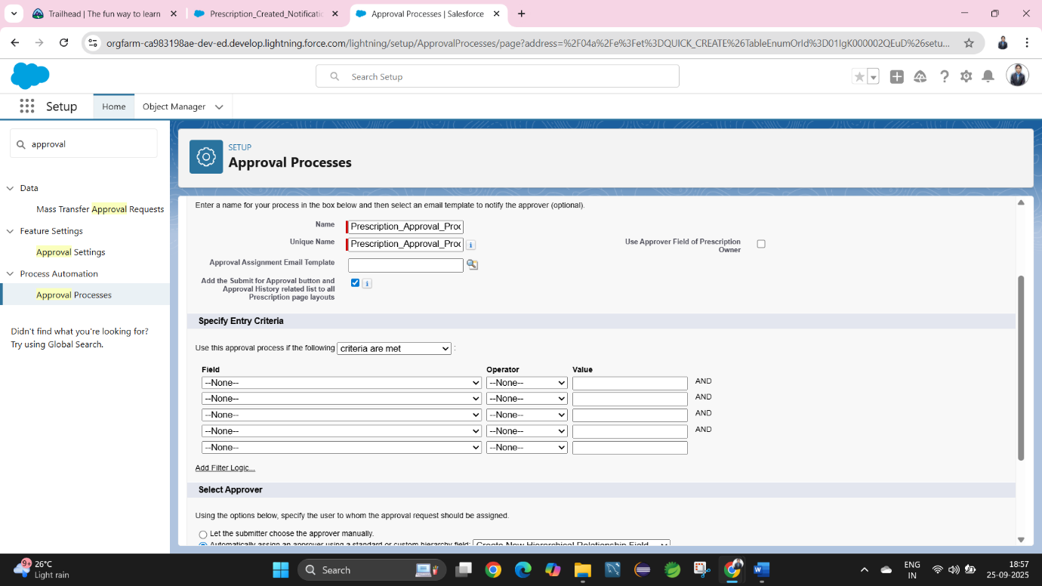

**5. Flow Builder(Optional)**

Salesforce Flow will be the **primary automation tool** going forward.

* **Screen Flow**: Patient self-service form to request a prescription refill.
* **Record-Triggered Flow**:
  + When a **Prescription__c** is created → Send Email + Create Reminder Record.
  + When a **Patient__c** record is updated with “High Risk” flag → Notify assigned Doctor immediately.
* **Scheduled Flow**: Daily check to send summary of missed doses to caregivers.
* **Auto-launched Flow**: Triggered from Process Builder to create Reminder Logs.

**6. Email Alerts**

* Templates for Patients, Doctors, Caregivers.
* Examples:
  + Appointment confirmation email to Patient.
  + Prescription refill reminder to Caregiver.

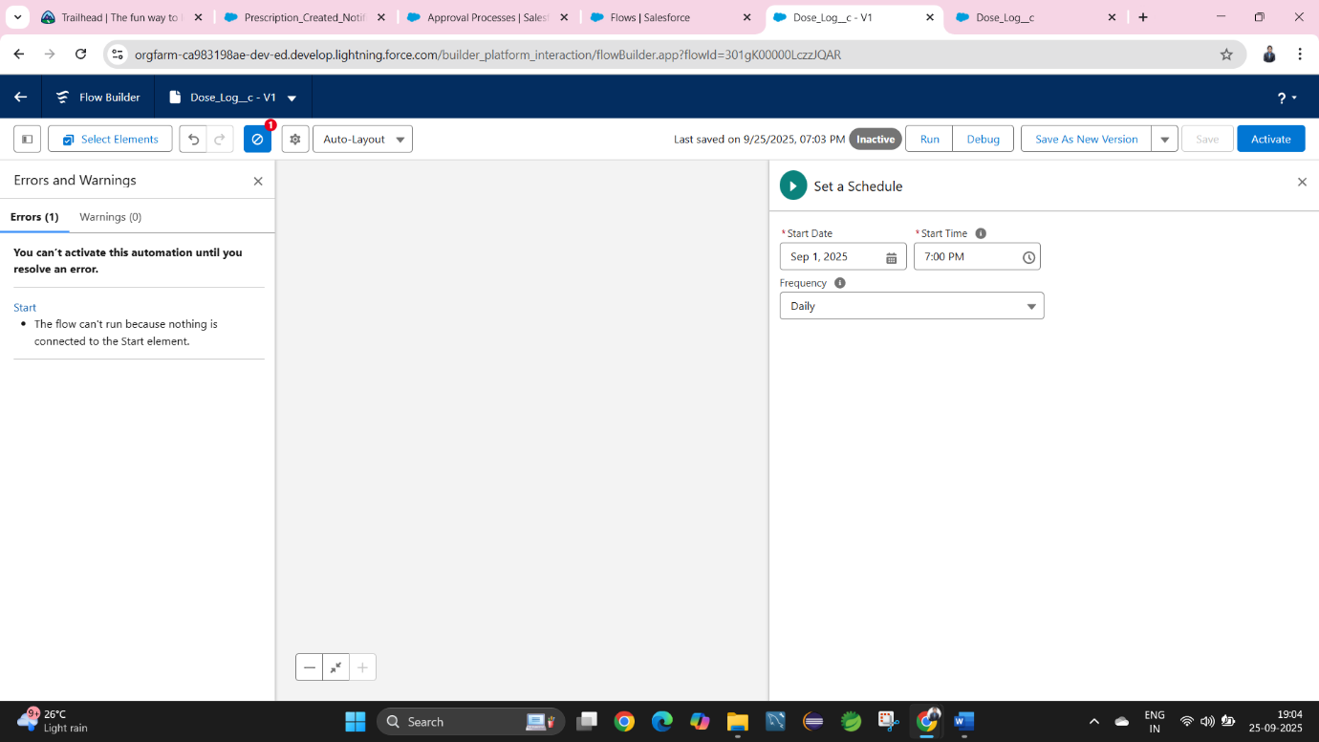

**7. Field Updates**

* Automatic updates on record fields.
* Example: When Appointment Status = Completed → Update “Last Appointment Date” on Patient__c.

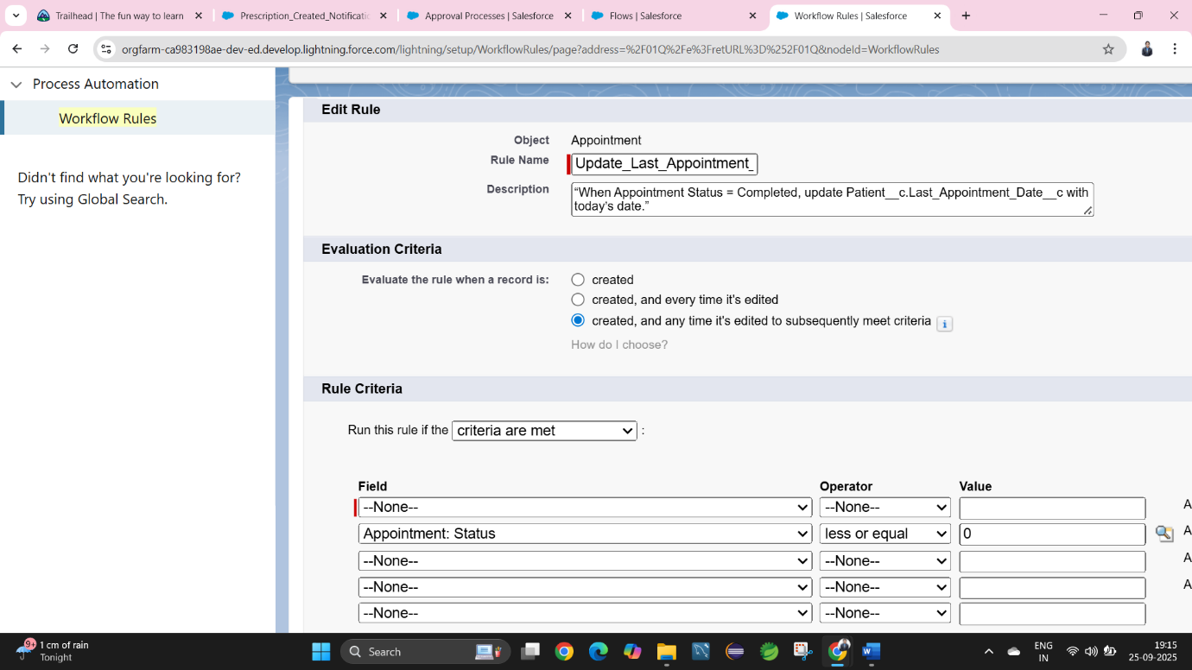

**8. Tasks(Optional)**

* Auto-create tasks for users.
* Example:
  + Assign task to Doctor after every missed dose report.

**9. Custom Notifications**

* Real-time alerts within Salesforce Mobile or Lightning.
* Examples:
  + Notify Doctor instantly when a patient misses 2 consecutive doses.

